Rivera-Batiz et al. (2020): “International trade theory and evidence: a survey” in Rivera-Batiz (ed.): Encyclopaedia of International Economics and Global Trade, vol. 3, ch. 4, pp. 85-144.

Introduction (p. 85)
…

The Classical Theory of Trade (p. 86)

Mercantilism / “Trumpism” → exports good, imports bad

Argument
- If value of exports > value of imports ⇒ surplus on trade balance → settled with gold or other assets → accumulate gold or other assets!
- If value of exports < value of imports ⇒ de-accumulate gold or other assets!

NB: Intertemporal argument, not analysing what trade does within one period
- Modern version / terminology → intertemporal trade (where trade balance may ≠ 0) ← O&R, ch. 1
Adam Smith (1776): Wealth of Nations
→
Trade can enhance welfare / “gains from trade” within one period

Consider trade in one period
NB: Trade theory assumes general equilibrium in one period ⇒ trade balance = 0 !!!

Classical trade theory
- Different endowments and/or different preferences ← simple cases (Exercise sets nos. 1 and 2)
- Different technologies
- Different factor endowments

Different endowments and/or preferences

- Different endowments (fish vs. wine), (amber vs. gold)
- Different preferences (yellow vs. black poppy seeds)

Different technologies

Absolute advantage and the gains from trade

Different countries are most productive in different products

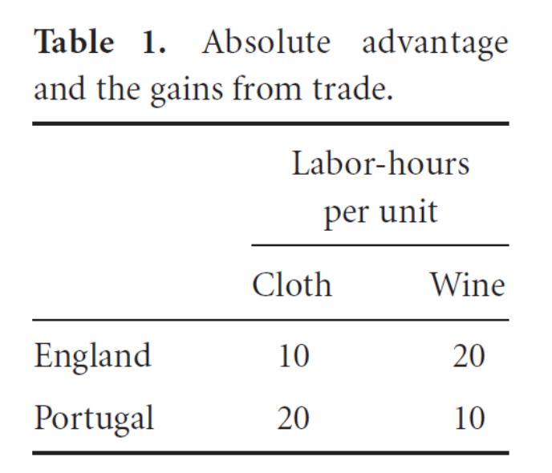
Absolute advantage → gains from trade
- England exports cloth to Portugal and imports wine (switch workers from wine to cloth production)
- Portugal exports wine to England and imports cloth (switch workers from cloth to wine production)
Marginal Rate of Transformation = MRT = “number of units of a product that must be foregone (given up) to produce one more unit of another good” (opportunity cost)

MRT = 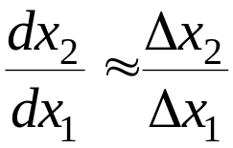 ← sometimes with minus sign –

Here: Good 1 = cloth, Good 2 = wine

MRT^{EN} = 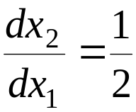 ← EN gives up 0.5 unit of good 2 (wine) for 1 unit of good 1 (cloth)
(opportunity cost of producing cloth instead of wine is low for EN)

MRT^{PT} = 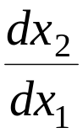 = 2 ← PT gives up 2 units of good 2 (wine) for 1 unit of good 1 (cloth)
(opportunity cost of producing cloth instead of wine is high for PT)

MRT^{EN} ≠ MRT^{PT} ⇒ all gains from trade not exploited
E.g.: EN produces 1 extra unit cloth, provides it to PT which is ready to give up 2 units of wine, but EN only requires (is willing to give up) ½ unit of wine ← surplus generated ← how to share/distribute this surplus?
Comparative advantage and the gains from trade

One country is most productive in all products…
… but is comparatively more productive in one of the products (comparative advantage)

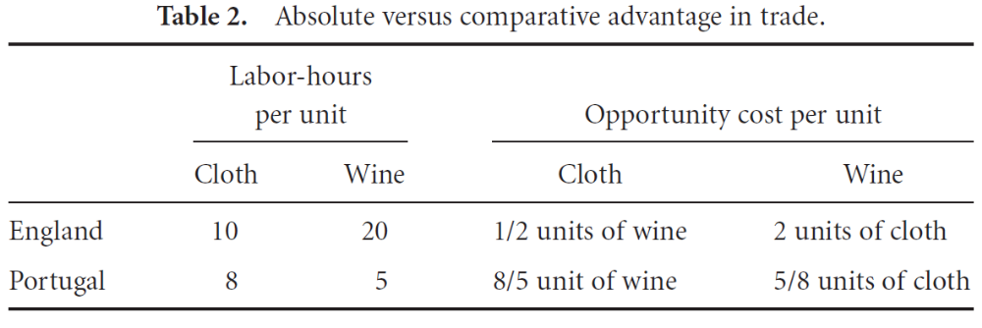

- The opportunity cost of producing wine in EN is much higher than in PT
- The opportunity cost of producing cloth in PT is much higher than in EE

Comparative advantage → gains from trade → England produces cloth, Portugal wine
- Country produces and exports product in which it has the highest relative productivity / lowest opportunity costs

MRT^{EN} = ← EN gives up 0.5 unit of good 2 (wine) for 1 unit of good 1 (cloth)
(opportunity cost of producing cloth instead of wine is relatively low for EN)

MRT^{PT} = 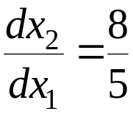 ← PT gives up  units of good 2 (wine) for 1 unit of good 1 (cloth)
(opportunity cost of producing cloth instead of wine is relatively high for PT)

MRT^{EN} ≠ MRT^{PT}, so trade ⇒ welfare gains

E.g.: EN produces 1 extra unit cloth, provides it to PT which is ready to give up units of wine, but EN only requires (is willing to give up) ½ unit of wine ← surplus generated ← how to share/distribute this surplus?

NB: MRT / opportunity costs (not the actual costs) important for the gains from trade!
The Ricardian Theory of Comparative Advantage: Empirical Evidence (p. 91)

Test empirically hypothesis → export products with highest relative productivity
- Here: some support → in study from 1962!

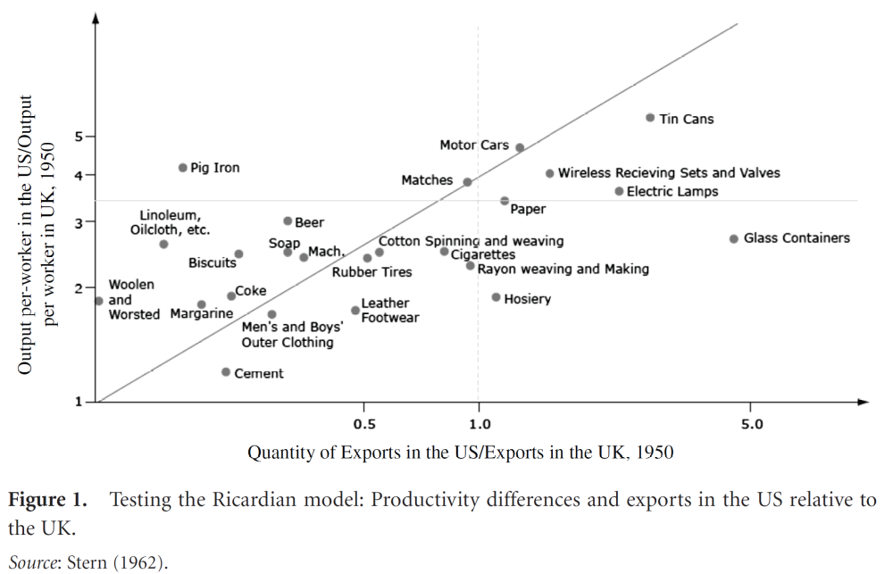

Factor Proportions and the Heckscher–Ohlin Theory of Trade (p. 95)

Different factor proportions

Not only one production factor (labour), but two (labour and capital)

Countries are differently endowed with production factors labour (L) and capital (K)
- Kenya vs. Germany

Assume neoclassical “well-behaved” production function with constant returns to scale and positive but diminishing marginal product of each production factor

Production of product i → Y_{i} = F(K, L), F_{K} > 0 and F_{KK} < 0, F_{L} > 0 and F_{LL} < 0

Production possibility frontier (PP) = combinations of two outputs (X, Y) which can be produced using two production factors
- Assumptions on production functions ⇒ nice concave PP

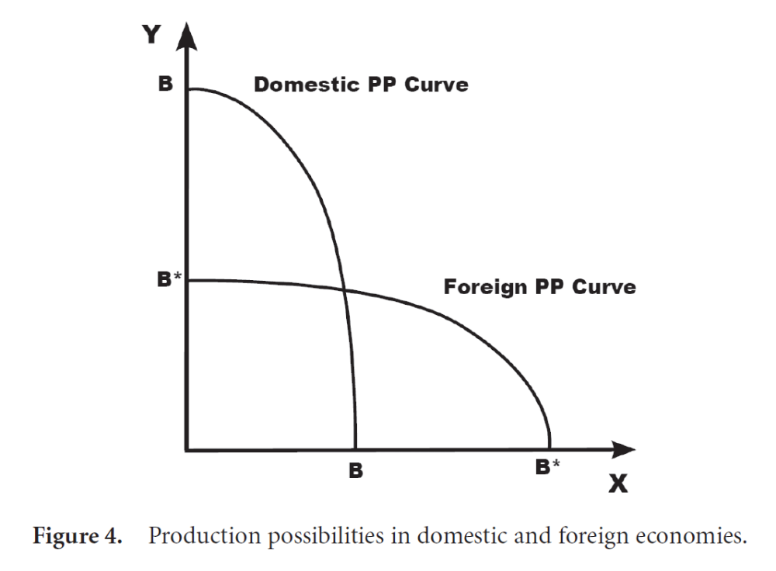

Consider autarky = no trade allowed → domestic production = domestic consumption

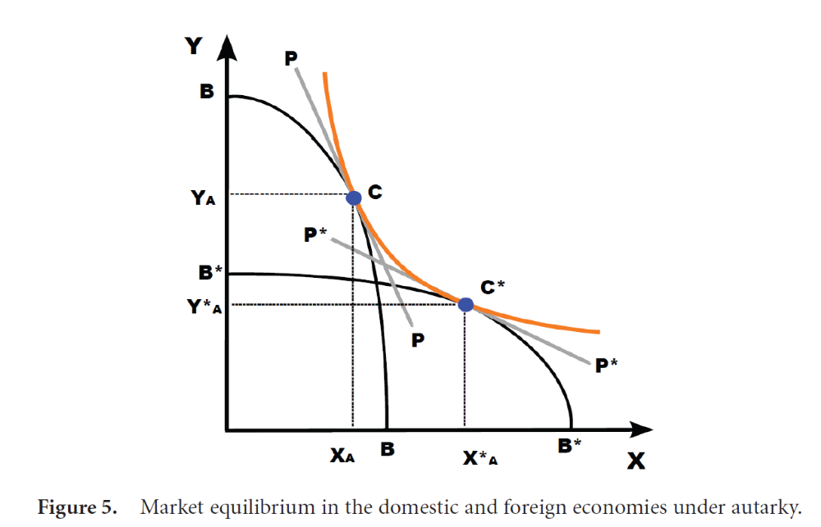

NB: Consumers have same preferences for X and Y in the two countries ← same indifference curve

When Free Trade (point FT) → changed product mix in two countries, trade, and higher utility in each country

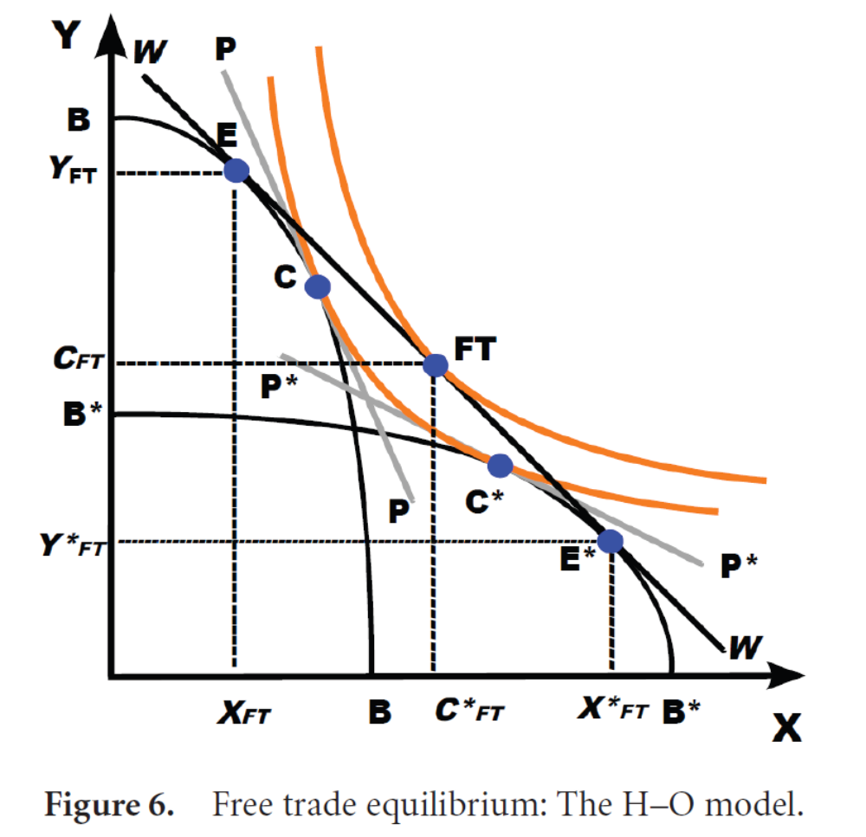

Heckscher-Ohlin → “countries export those goods that require for their production the intensive use of those factors of production that are relatively abundant in the economy”

→

Intuition: If abundant labour ⇒ labour is comparatively cheap ⇒ produce good that uses a lot of labour in its production and export it
- Proof a little complicated (but partly in article; see Figure 6)

Sectoral reallocation → product prices change ⇒ change in the return to production factors
- Stolper-Samuelson theorem → “an increase in the relative price of a good leads to an increase in the price of the factor used intensively in the good’s production”
- Factor price equalisation theorem → “trade equalises or tends to equalise (reduce gap in) factor prices across countries”
- Rybczynski’s theorem → “when the stock of a factor increases, production of the good that more intensively uses that factor increases as well”
  - Changed production structure (but not (necessarily) lower returns to the factor added)

Empirical Evidence of the Factor Proportions Theory (p. 107)

Heckscher-Ohlin → “countries export those goods that require for their production the intensive use of those factors of production that are relatively abundant in the economy”

The Leontief Paradox → USA exported (in 1947, sic!) much of labour-intensive products, but not so much of capital-intensive products

Explanations
- Maybe USA was not so capital abundant, and not so labour scarce
  - Labour → hours worked + human capital
- Measurement problems → calculating relative labour and capital intensities is complicated!
  - In practice, many products, many production factors

Market Structure and the New International Trade Theory (p. 115)

Krugman etc.

Consumers
- Consumers like variety / different variants
- Cars → VW, Peugeot, Fiat, …
- Varieties of cornflakes
- Bottled water → EE, LT, ES, MK, …

Producers
- Increasing returns to scale (e.g. FC + constant MC)
- If perfect competition → p = MC ⇒ Profit < 0 (as FC not covered) ☹
- Monopoly in specific variety ⇒ p > MC ⇒ this variety of product can be produced

Given FC, inefficient that all countries produce all varieties (as FC then has to be paid for all of the varieties)
→
International trade in varieties (intra-industry trade) is welfare enhancing → country produces some varieties and sells them at home and abroad, and then imports other varieties

Firms, productivity and international trade (p. 126)

New new trade theory

EE → Jaanika Meriküll, Priit Vahter, Jaan Masso

Until now → trade in final products, i.e. products that directly enter utility function of final consumers

In reality → “Close to 70% of world trade consists of intermediate goods and services” → goods and services produced in exporting country but input in production in importing country

Global Value Chains (GVC)
- Extreme exploitation of comparative advantages and/or specialisation in varieties
- GVC can be long (e.g. aircrafts, car, IT)

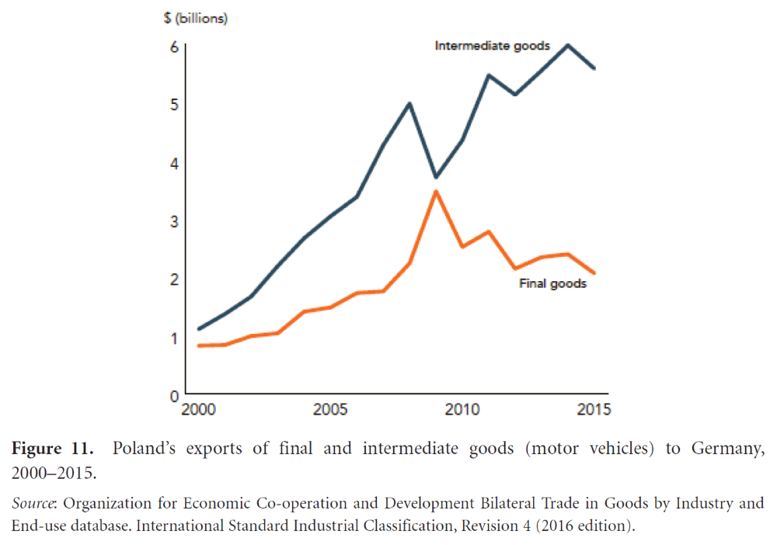
Linkages between trade and firm productivity become important
→
Argument → trade ⇒ positive effect on (aggregate) productivity
- “Creative destruction”
  - “The focus on firm heterogeneity introduces a new source of the gains from trade: Trade liberalizations are often accompanied by the exit of low productivity firms and the expansion of high-productivity ones...”
- Anticipation effects, cf. Porter
  - “Complacency and an inward focus often explain why nations lose competitive advantage”

Some empirical evidence of productivity-enhancing effects in firms if exposed to trade, cf. also Priit Vahter’s studies

Stiglitz → “What matters is dynamic comparative advantage, or comparative advantage in the long run, which can be shaped”.

“The notion that comparative advantage can be influenced and changed has given rise to the adoption of so-called industrial policies”
→
“Industrial policies seek to shift trade patterns from industries that have a static comparative advantage but have minimal growth potential to those that may have a dynamic comparative advantage and therefore strong long-run growth prospects”.

Full circle, neoliberal regime questioned, restrictions and duties on trade
- EU, USA, China
- Draghi report in 2024
- Trump?

Conclusions (p. 133)

Read yourself!

